Thank you for your sponsorship!

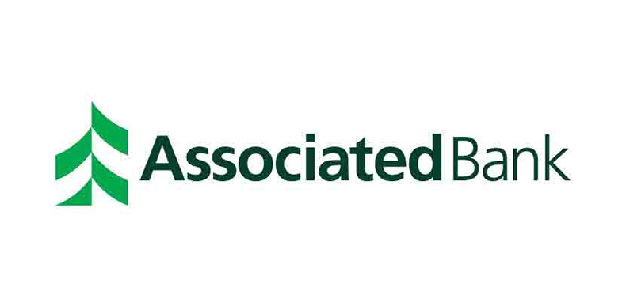



## 

## 

## Taste of College Mundelein

**Mundelein High School**



**April 25, 2018**

**5:00-7:00**

5:00 PM-7Pm

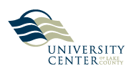

**Participating Colleges**

College of Lake County

Trinity International University

University Center of Lake County

**Participating Schools**

Carl Sandburg Middle School (District 75)

Fremont Middle School (District 79)

West Oak Middle School (District 76)

Mundelein High School (District 120)

**Taste of College Committee**

Christine Anderson - Trinity International University

Carolyn Brugioni - College of Lake County

Anthony Crespo -Mundelein High School

Luis Fuentes - Community Liaison, Remax/Broker Associate

Gretchen Garza - Carl Sandburg Middle School

Nora Mena -University Center of Lake County

Dr. Myra Gaytan-Morales -University Center of Lake County

Pam Motsenbocker - Freemont Middle School

Mark Pilut -Carl Sandburg Middle School

Sarah Stashkiw - College of Lake County

Nicole Seibt - Carl Sandburg Middle School

Dr. Hilary Ward Schnadt - University Center of Lake County

Christopher Willeford - West Oak Middle School

**Taste of College Mundelein Recognition Ceremony**

**5:00 p.m**. Parent Workshop: College Readiness

Carolyn Brugioni*, College of Lake County*

Dr. Myra Gaytan-Morales, *University Center of Lake County*

**5:30 p.m.** Dinner

**5:50 p.m**. Welcoming Remarks

**6:00 p.m.**Certificate of Recognition

Mark Pilut*, Principal, Carl Sandburg Middle School*

Pam Motsenbocker, *Principal*, *Fremont Middle School*

Christopher Willeford, *Principal, West Oak Middle School*

**6:45 p.m.** Closing Remarks

Luis Fuentes*, Universidad de Padres, Mundelein High School*