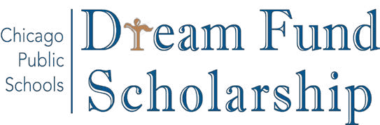

OUR STUDENTS NEED YOU!

The CPS DREAM Fund Scholarship is a talent and need-based, last dollar award to assist academically talented undocumented immigrant CPS students going to college.

To make a tax-deductible donation online:
1. Go to: tinyurl.com/CPSDREAMFund
2. Click on “Make a Monetary donation”
3. Under “Designation” type “CPS DREAM Fund”
4. Create an account
5. Select payment option and confirm your payment

or

To make a tax-deductible donation by check or money order:
1. Make a check/money order payable to “Children First Fund”
2. Your memo line must read: CPS DREAM Fund
3. Mail it to: Chicago Public Schools, Children First Fund, c/o Luis Narvaez, 42 West Madison Street, 2nd Floor, Chicago IL 60602

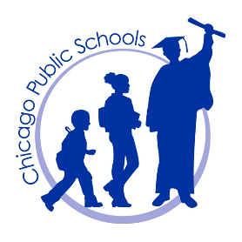

Questions? Email them to Luis Narváez,
Scholarship Campaign Manager
LNarvaez2@cps.edu / 773-553-2077

